**NAAN MUDHAVAN**

**ASSIGNMENT DOCUMENT**

**COURSE TITLE** : DIGITAL MARKETING

**COLLEGE CODE** : 1105

**COLLEGE NAME** : GOJAN SCHOOL OF BUSINESS AND TECHNOLOGY

**NM ID** : 413CF44DD41D9C2B7834C927CAF7B935

**NAME** : AKASH R

**REGISTER NUMBER** : 110520106305

**YEAR** : 4TH YEAR

**DEPARTMENT** : ELECTRONICS AND COMMUNICATION ENGINEERING

1. Create a blog or website using Blogspot and Wordpress. Customize the theme design and post new article with 500 words.

Link: https://digitalsales2k23.blogspot.com/2023/09/welcome-to-digital-marketing.html

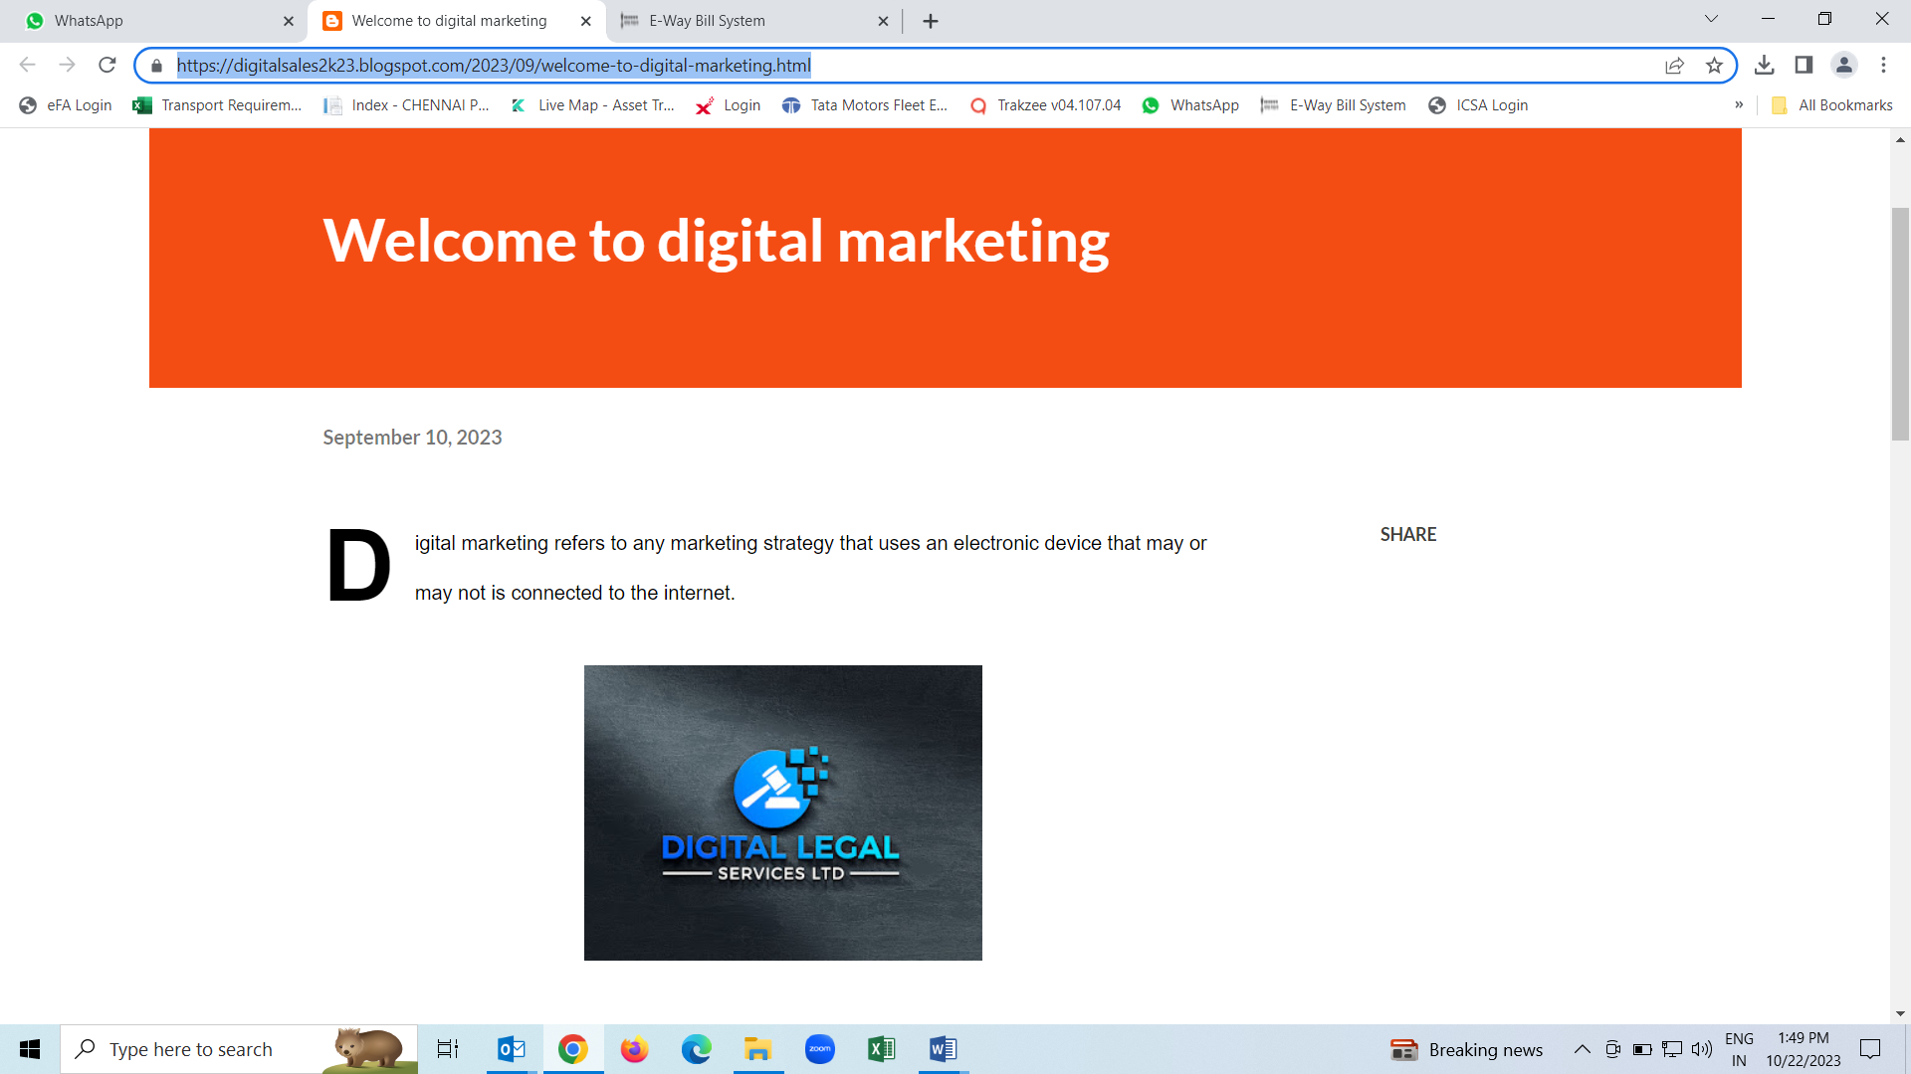

1. Create a New Facebook Business Page and post one social media poster for your brand.

Link: [https://www.facebook.com/digital.sales.marketing.2023?mibextid=ZbWKwL](https://www.facebook.com/digital.sales.marketing.2023?mibextid=ZbWKwL%20)



1. Create and design a social media advertisement poster using canva.



1. Create email newsletter design using MailChimp or canva tool.

Link: https://digitalsales2k23.blogspot.com/2023/09/email-newsletter-digital-marketing.html

